LAB EXPERIMENT NO # 06
Name: __________________________________ Date: ________________________
Score: __________________________________Signature of Instructor___________
Series-Parallel Circuits
PERFORMANCE OBJECTIVES:
- Identify a series-parallel circuit.
- Accurately measure voltages and current present in a series-parallel circuit.
- Verify measurements with calculated values
EQUIPMENT AND COMPONENTS:
- Multimeter
- Power supply
- Connecting Leads
- Breadboard
- Few Resistors
- Ohmmeter
- Voltmeter
- Ammeter
INTRODUCTION
Consider the circuit shown in Figure 1. Resistors connected together as shown are often called a resistor network. In this network, resistors R2 and R3 are considered to be in parallel arrangement. Also, this parallel arrangement is in series with R1. To calculate the total resistance Rt, the equivalent resistance of R2 and R3 must be determined, where
R_{eq}= (R₂×R₃) / (R₂+R₃)
Therefore, the equivalent resistance of this parallel arrangement can be calculated by Req.
The total resistance is now easily found by adding the two resistances R1 and Req, where
R_{T} = R₁ + R_{eq}

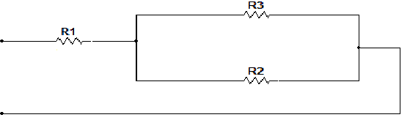

FIGURE 1
PROCEDURE:
- Connect the circuit shown in Figure 1 take the values of source voltage and resistances of your choice and availability in the Laboratory.
- Calculate, measure and record the voltage and current across all resistors also find total current and record the result in Table 1.
- With the voltage source removed measure, calculate and record Rt in Table 1.
- Calculate the percentage of error for Table 1.
- Construct the circuit shown in Figure 2 by taking the values of voltage and resistances of your choices and availability in the laboratory.
- Calculate , measure and record the all voltages and currents for Figure 2 and fill the Table 2 correspondingly.
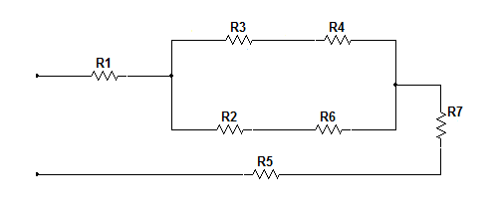

FIGURE 2

TABLE 1
VALUE | CALCULATED | MEASURED | % ERROR
V₁
V₂
V₃
V_{T}
I₁
I₂
I₃
I_{T}
R_{T}

TABLE 2
VALUE | CALCULATED | MEASURED | % ERROR
V₁
V₂
V₃
V₄
V₅
V₆
V₇
V_{T}
I₁
I₂
I₃
I₄
I₅
I₆
I₇
I_{T}
R_{T}
CONCLUSION:

